**“Santa’s Troubles”**

**Create a Memorable Christmas Event**

**For your Company,Group,**

**or as a fundraiser.**

**Bring this One Act from rehearsal to performance in 6 hours or less.**

**No Experience Necessary**

**Staging Guide Included**

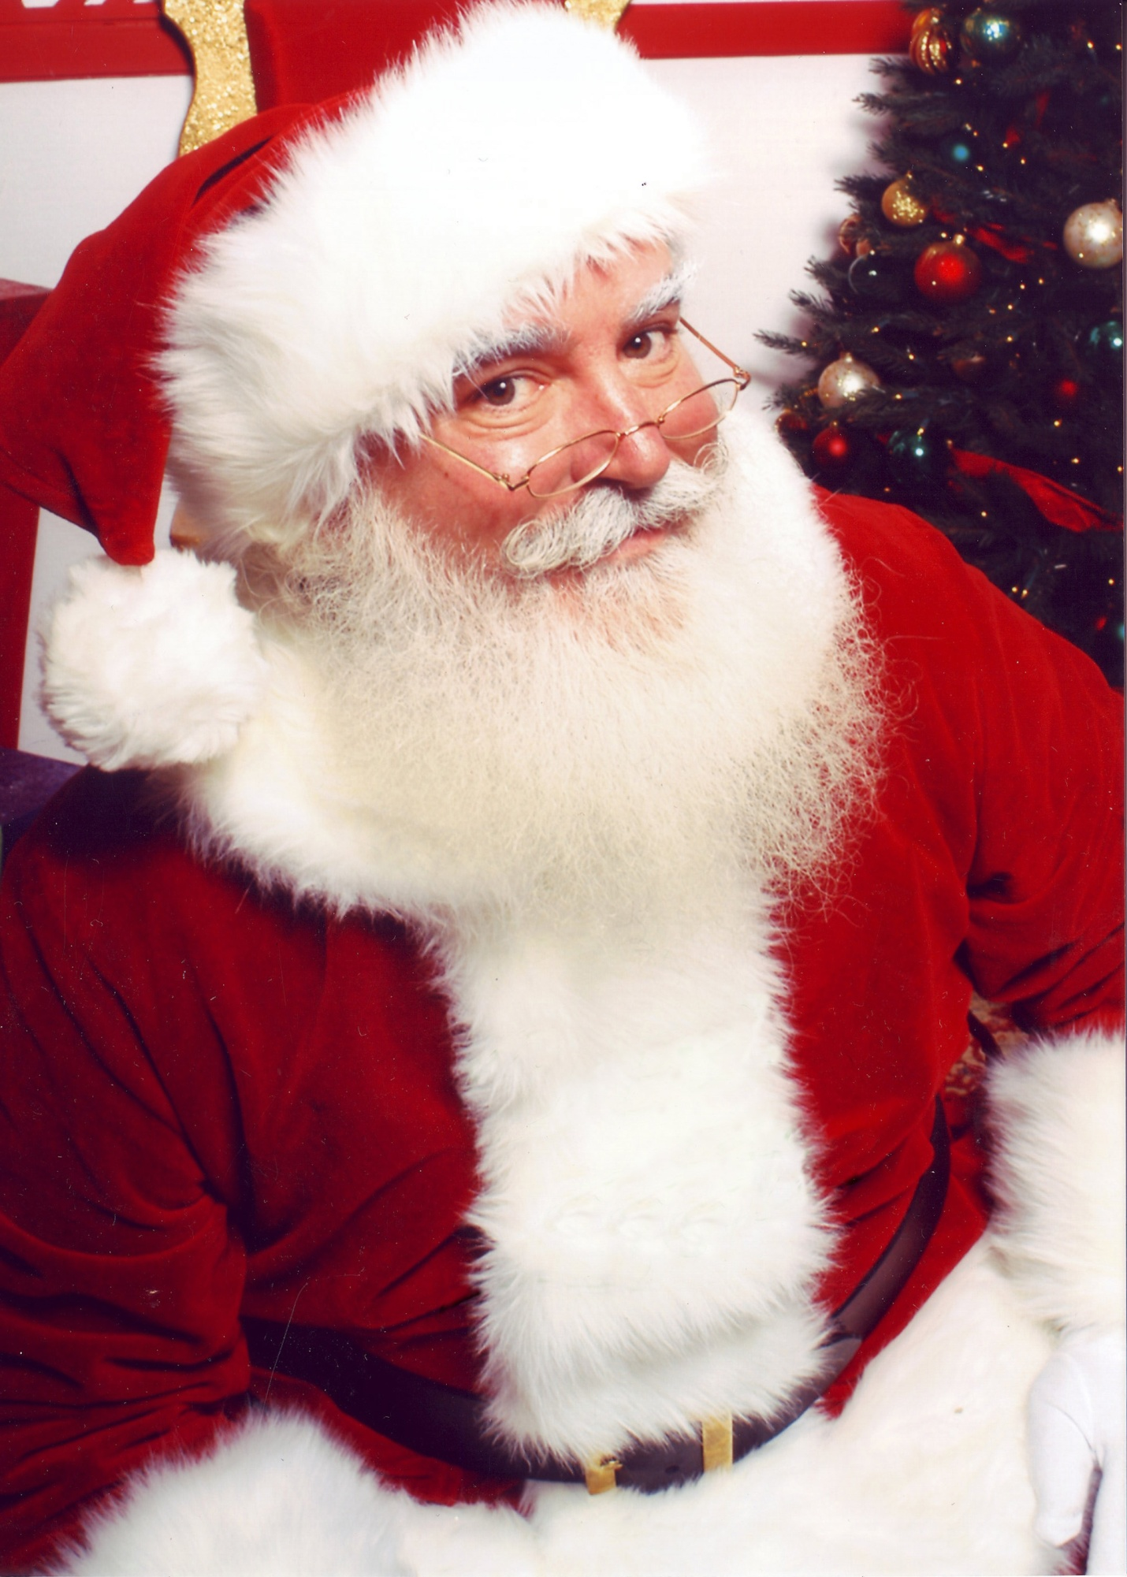

**Reduced Licensing Fee: $95.00**

Copyright © 2012 Xanadu, Inc. and Joseph Beach



All rights reserved.

Xanadu Inc. 11348 Statton Ave S

Eden Prairie, MN 55344

Xanaducorporate@gmail.com

652-240-6710

WWW.Xanaducorporate.com

DEDICATION

To the wonderful cast I work with and our wonderful audiences.

**Our Liberal Use and Purchase Conditions**

1. **If you intend to produce the play you can copy the script.**
2. **You can cut, edit or change the play in any way. This includes scaling the play to the length you want. Remember “Santa’s Troubles” is copy write protected and royalties are due for the use of any part of “Santa’s Troubles.”**
3. **You may use the materials in the book for promotion. You may video tape your performances.**
4. **A royalty is due prior to performance any time all or part of a play is performed in front of any size audience, whether or not admission is charged.  This includes school assemblies and audience-attended “dress rehearsals.” This includes readings of the play.**
5. **For amateur groups royalties are $95.00 for upto 3 performances. If you pay your actors a union equivalent wage you are considered professional. Professional groups must contact Xanadu.**

**Author Note**

**I love the magic of the holiday season, all of our mythical characters, and the whole of live participatory theater. One of my best audiences numbered twenty at a church lunch, another, a company Christmas gathering. Stage it for the fun of it, as a fund raiser, or as a theater experience. Whether you are high schoolers or seniors citizens, staging “Santa’s Troubles” is easy and your audience will love it. Energy is the only acting requirement. Let me know how it goes. Joe Beach**

**Do it without memorization**

**Script**

**[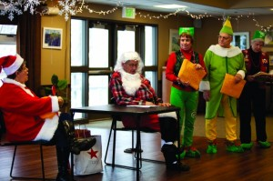](http://pressnews.com/wp-content/uploads/2012/12/MGsantaRetires4.jpg)**

**Script**

**Just Bring Energy**

**Laugh at yourself Laugh at the funny dialogue & jokes**

[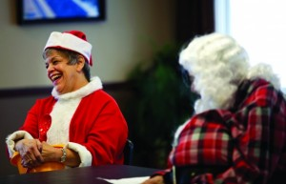](http://pressnews.com/wp-content/uploads/2012/12/MGsantaRetires5.jpg)

**Pillow inside wool shirt**

**Don’t over think cues or acting**



**“Santa’s Troubles” is a very funny, zinger filled play. It will carry any mistakes.**

C:\Documents and Settings\Joe Beach\Local Settings\Temporary Internet Files\Content.IE5\6W4ZG13F\MC900423159[1].wmf

**Don’t Worry About Acting**

C:\Documents and Settings\Joe Beach\Local Settings\Temporary Internet Files\Content.IE5\BZVKNKRA\MC900097507[1].wmf

**It is more important to simply be the character than to act. For the most part your audience beyond the first row of tables or chairs will not see facial expressions.**

MC910217233[1]

**Depression is conveyed with a shuffle and bent head. A slow long entrance by the bedraggled good fairy has great theater affect. Moving from sitting to standing and exiting are grand gesture opportunities. Just moving about creates theater.**

**Use Big Gestures**

**Exaggerate where you can !!**



**With this Play**

**Goofy is Good**

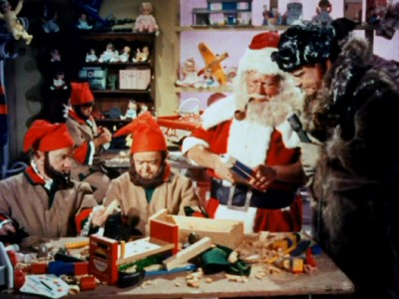

**It’s Not in the Detail**

**To Get Started**

MC900446010.WMF

**Sit at a table and read**

**the script several times.**

**At this point you could put on**

**a reading only performance.**

**Then try it a few times with blocking.**

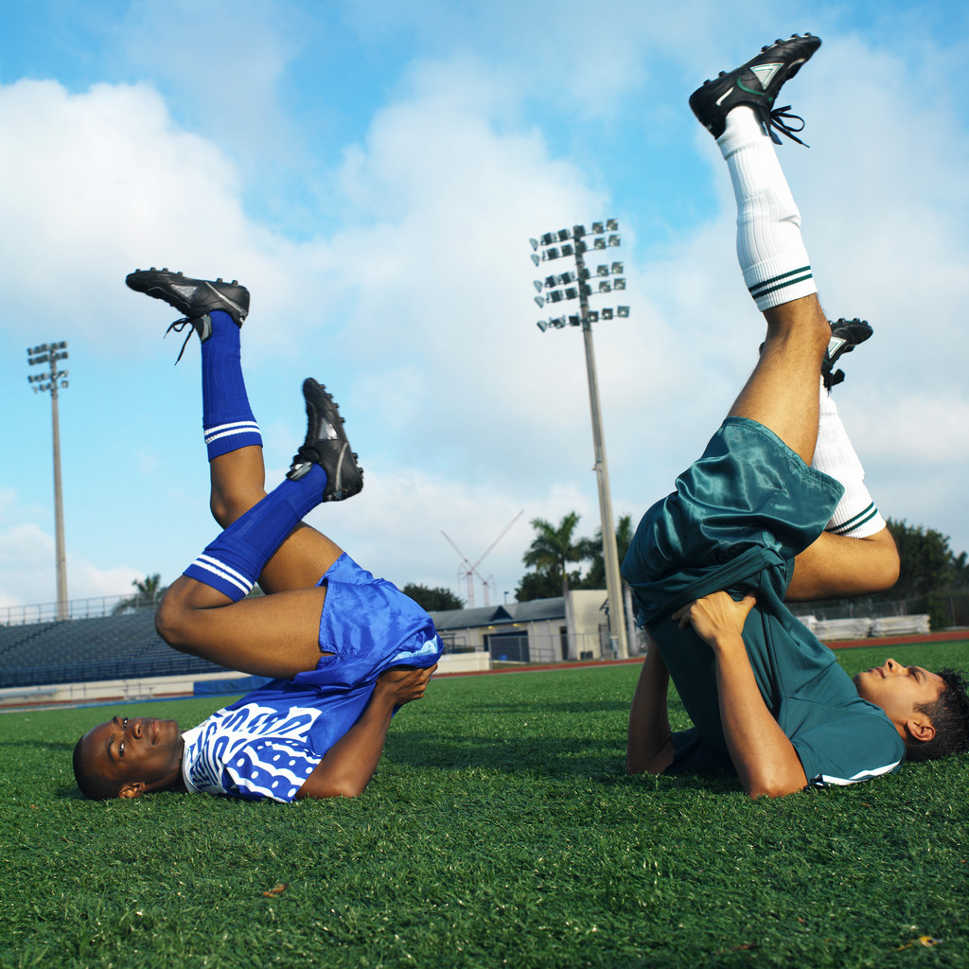

MC900140891.WMF

MC900198604.WMF



**Elf 1 Enters & Starts right in. A podium is ideal.**

**Enter Santa followed by Elf 2. A table is ideal for Santa. As Elf 1 gets to the poem parts for props, Elf 2 takes props out of the bag. Insert some banter by Elf 2 and Santa.**

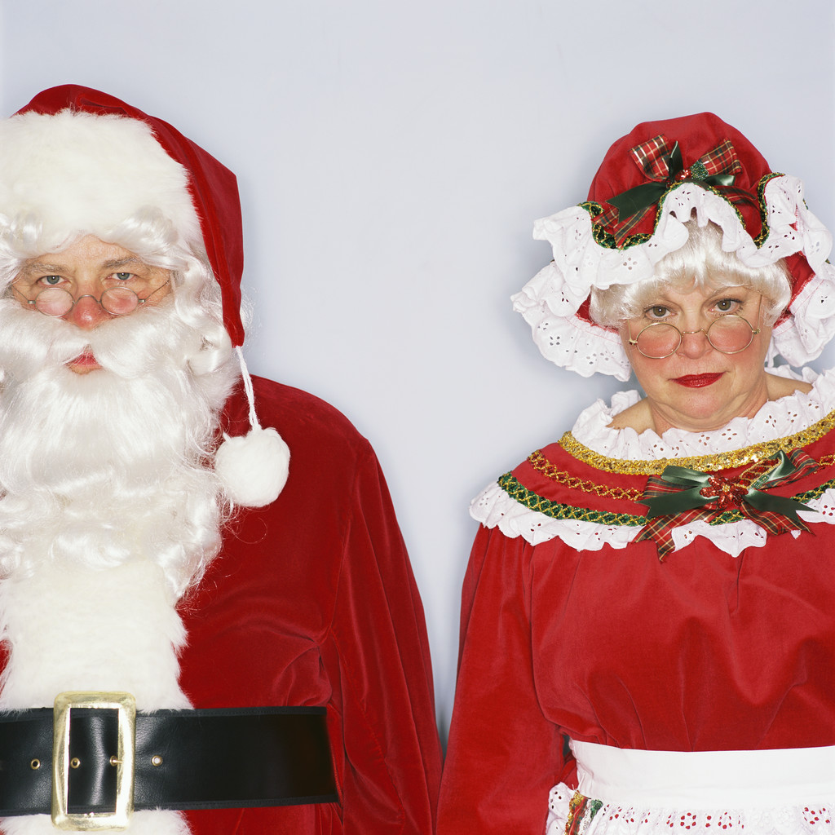



[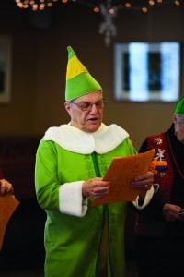](http://pressnews.com/wp-content/uploads/2012/12/MGsantaRetires3.jpg)

**Elves leave and Clara Claus enters, joining Santa at the table.**

**Elves enter, read letters, Clara exits, Elves complain to Santa and exit**

**With the cue “a friend to help you” the Easter Bunny enters hopping.**

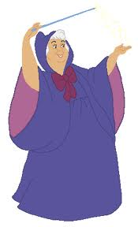

MC900295892.WMF

**Clara announces the arrival of Fairy Godmother.**

**Fairy Godmother: “Call the others in.”**

**The Grand Ending**

**Curtain**

**Next Pretend you are holding a microphone. This affects how you deal with your script, note cards, and props. Typically, the cast will need to share a microphone(s). Even if you have a strong voice using the microphone will enhance the performance. Learn how to talk into a microphone**





**Less Script Use is Better**

**Put your part on cards. Start trying to summarize.**

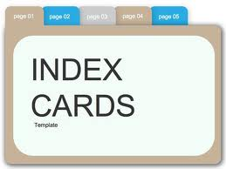

**Some of the lines and cues will become easy and you will need only a word or two on your cards. This is a good exercise even if you are using a script.**

**The hardest part of acting is listening**

**At your next rehearsal concentrate on your cues, laugh lines, and key words. The better you know your part the better you can listen.**

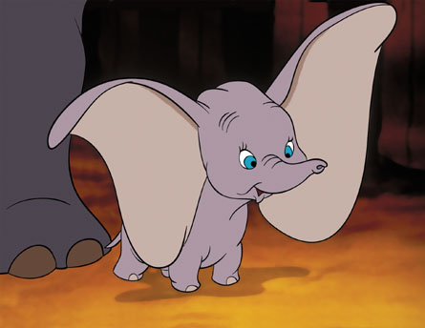

**Remember it’s a Comedy**

**Anticipate laugh lines. It’s not a race through your part. Give the audience time to react.**

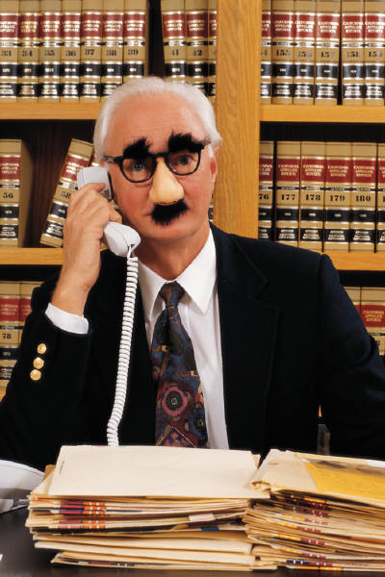

**The audience does not know your lines. They do not know that a line was changed or even missed. The only thing you need to prevent is long blank pauses. Don’t get hung up on specific wording. Just keep going.**

For one performance I played Santa right after eye surgery. I literally could not read the script (I use one page of notes just to pick up the cues.) I bumbled my way through Santa’s alliterative line: “It’s another terrible, tumultuous, treacherous, treasonable, tormenting, tradition breaking, technological turn. “ I got enough so the audience got the ideal and they loved it.

In another performance: **Bunny:** “Dr Oz says green coffee beans melt the fat away. **Santa’s missed line:** “. We all know nothing melts away at the North Pole, not even this. (Santa pats his belly). **Bunny simply picked it up.** Forget Dr. Oz. You just aren’t yourself.” The audience didn’t know that they missed a bad joke.

**Costumes**

**Costumes certainly don’t need to be perfect.**

**Couldn’t talk with the beard in place**

[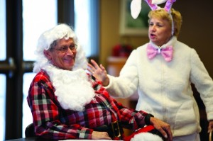](http://pressnews.com/wp-content/uploads/2012/12/MGsantaRetires.jpg)

**We purchased one Santa outfit. Mrs. Claus uses the jacket. Hats came from a dollar store. Elves do not need to be identical. Our Fairy Godmother wears a black sequin dress with a pair of children’s fairy wings. Somehow the Easter Bunny found a real costume. Just ears and a pink top will do.**

[](http://pressnews.com/wp-content/uploads/2012/12/MGsantaRetires4.jpg)

[](http://pressnews.com/wp-content/uploads/2012/12/MGsantaRetires5.jpg)

**Props & Sight Gags Work**

**Gather a few props for Santa’s bag. Something of fur, something that makes noise, a pipe, a candy cane, and you are ready to start….See production notes.**



C:\Documents and Settings\Joe Beach\Local Settings\Temporary Internet Files\Content.IE5\YDO63TP3\MC900312732[1].wmf

**This Never Fails**

Fa

**Noise is Good**G



**You are not under a Microscope**

**Just be the character as best as you can. Mrs. Claus and Santa are concerned, The Easter bunny energetic (no pun intended), Fairy Godmother flighty and helpful and the Elves semi-disgruntled employees.**

**And Don’t Worry – Be happy**

**Your Audience Will Love It !!!**

**Santa’s Troubles**

**Elf 3:** Hello. I’m Elf #3. Happy holidays everyone. It is great to see you here in (local reference). Sadly I must report to you that everything in not hunky dory at the North Pole. In these days of Kardashian’s 72 hour marriage, overwhelming technology, and do nothing legislators, it is hard to keep the Christmas spirit.

It was a nicer time when we could visit the Cleavers and Ozzie and Harriet, when we could say “I like Ike.” It’s almost impossible to be politically correct. We elves don’t know if we are dwarfs, midgets or simply little green people.

To show our frustration we elves wrote this poem.

T’was the night before Christmas and all through the land

Good Samaritans couldn’t stop or lend a hand.

When people heard us on the roof tops.

They called the fire department and cops

The runners were removed from Santa’s sleigh

They were termed dangerous by the EPA.

Our flight plan was rejected by the FAA

They told us to find another way

Short we elves can’t be called

Vertically challenged has evolved

And we must be very wary

When referring to the tooth fairy

Second hand smoke from Santa’s pipe

Caused the Surgeon General to gripe

And if you have any doubt

Look at the gifts that are now on the out

Nothing of leather, nothing of fur

PETA says no, no sir.

**Elf # 2:** No sir, nothing of fur. (Elf # 2 is wearing something of fur but makes no move to take it off.)

**Elf # 3:** I said nothing of fur.

**(Elf # 2 removes fur):**

**Elf #3:** Toy drums and whistles were always fun

Now forbidden – sound pollution

**Elf #1** (Pulls something a noise maker out of the bag) Nothing that makes too much noise

**Elf #3:** And with every toy you can bet

There must be a safety strap or helmet

Nothing showing gender in the toys

Nothing for just girls or just boys

A gift for grandma if you dare

As long as it is pre-approved by Medicare.

Worst of all no cookies or cake

It’s a different world for Pete sakes

**Elf # 2:** (pulls out candy) No sugar

**Santa: (**Strongly) No sugar, Why I’ll waste away

**Elf # 3:** Santa tried to be merry he tried to be gay

But you’ve got to be careful with that word today.

The rules and regulations took their toll

Things were a changing at the North Pole.

His sack was quite empty, limp to the ground

Nothing fully acceptable was to be found.

(Elf # 2 hold up empty sack)

Things have gotten so very dire

That Santa has decided to retire.

Worse yet said with a sob

There’s no one to take over his job

It all seems so unfair

Santa has no children, no heir

(Mrs. Claus enters and the elves retreat).

**Santa:** You know Clara, lately all we get is bad news.

**Mrs. Claus:** What is it now?

**Santa:** The internet is threatening to eliminate the post office, the number of children on the naughty list is growing, and we have labor problems.

**Mrs. Claus:** You have solved changes before. Remember when you first ran across houses without chimneys.

**Santa:** This is worse. Some guy in cyberspace is taking over my job.

**Mrs. Claus:** This explains why you have been acting so strange lately. I thought you were just by bi-polar.

**Santa:** What do you mean?

**Mrs. Claus:** The other day the phone rang and you picked up the remote and starting talking into it.

**Santa:** Everyone does that. They look alike. Anyway, it could have been your mother and the TV remote has a pause button.

**Mrs. Claus:** Then you went to the kitchen to make a sandwich and spread peanut butter all over your hand.

**Santa:** I was making a finger **sandwich.**

**Mrs. Claus**: Joke as much as you want.Yesterday you asked for the keys to the sleigh. After the first three hundred years you should know it’s keyless.

**Santa:** Alright. I’m like Rodney Dangerfield. I just don’t get any respect. I’m thinking about retiring.

**Mrs. Claus**: Retire! Have mercy on me. We only have a couple of hundred closets to clean. Then what?

**Santa:** All of these new rules and technology. It’s too much.

**Mrs. Claus**: But you can’t retire. Remember the contract. You can only be replaced by someone in the family. It’s a clause in the contract. It’s the Santa Claus clause.

**Santa:** Without a little Claus I can still can quit.

**Mrs. Claus**: I knew you were troubled. That is why I have invited a friend to help you.

(Enter Easter Bunny).

**Santa:** Didn’t I meet you before at the playboy mansion?

**Bunny:** As you can see I’m a different kind of bunny. I am the Easter Bunny.

**Mrs. Claus:** What were you doing with playboy bunnies?

**Santa:** I was shopping, but it’s a secret. (Aside to the audience) Victoria’s secret.

**Bunny:** I hear you are not feeling well.Maybe we should take your temperature. You might have Tintsilities or Hollytosis. Maybe an angiogram. We Easter bunnies are good at injecting dye.

**Santa:** No, nothing medical. Nothing that Nutrisystem or a Dr OZ diet will not solve.

**Bunny:** Dr Oz says green coffee beans melt the fat away.

**Santa:** I think he really is from OZ. We all know nothing melts away at the North Pole, not even this. (Santa pats his belly).

**Bunny:** Still, you are not your usual jolly self.

**Santa:** The only disease I have is a computer virus. I can’t give encyclopedias away anymore because of Wikipedia and the children want a twitter telling them what time I will arrive.

**Bunny:** The same technology thing happened to me when all of the TV’s went digital. They eliminated all the TV rabbit ears. It used to be so much fun putting aluminum foil on them.

**Santa:** What’s your secret? You’ve been around as long as I have.

**Bunny;** I just keep it simple. I put out the baskets of candy and eggs early in the morning and I’m done. Then we bunnies get together and play our favorite game.

**Santa:** Your favorite game?

**Bunny;** Hop scotch, of course. (Turning to Mrs. Claus) Clara, keep up your spirits. Maybe we could have lunch at my favorite restaurant.

**Mrs. Clause**: What is your favorite restaurant?

**Bunny:** The I-hop of course. Or maybe we could have a beer.

**Mrs. Claus**: I didn’t know rabbits liked beer.

**Bunny:** It’s the most fun way to get our hops. Which reminds me, I have a movie audition. I never get beyond the first audition before I am cut. We call it a hare cut. (If there is no laughter add “That’s H.A.R.E.”) Santa please don’t turn tail.

**Mrs. Claus**: Bunny doesn’t seem distressed by the changing world.

**Santa:** Bunny doesn’t have parents and grandparents who are ordering presents on line. Then the presents are delivered by some guy in a brown suit. My sled is being replaced by the UPS truck.

**Bunny:** I would be happy to help deliver toys but all I have is a Volkswagen Rabbit. Good luck Santa. As my mother used to say, hop to it. (Bunny exits, waiving.)

**Mrs. Claus**: You could ask Santa for a computer.

**Santa:** Very funny.We are at the North Pole. Haven’t you hear about computers freezing up. I’m just too far behind all this technology. If you ask me, twittering should left to the birds or Trump. I’m going to give it up.

**Mrs. Claus**: But what about all the good children. Millions still send you letters.

**Santa:** I’d rather get junk mail. You will see. Here come the elves with today’s batch.

**Elf # 2:** Here’s the mail but you are not going to like it.

**Santa:** I know, but read them anyway.

**Elf # 2:** Dear Santa, You look scruffy. Get a razor. You look like a fat polar bear. Julie age 10.

**Santa:** No respect.

**Elf # 1:** This is from Nicole age 7. Everything I got says made in China. Have you moved from the North Pole?

**Santa:** See, she thinks I’ve retired to China.

**Elf # 3:** This one is from Barry age 8. Last year I got a new baby sister. She is no fun to play with. Can I trade her if for something that doesn’t poop?

**Elf # 2:** This one is from the White House. Dear Santa, Please stop giving kids the game Candyland. It delivers the wrong message. Rename it vegetable land. Michelle Obama,

**Santa:** A new Bing Crosby Song.– It’s a white house Christmas.

**Mrs. Claus:** (exiting) I feel the sudden craving for pickles and ice cream with some potato chips...

**Elf # 3:** Santa, we want totalk about our outfits. The pointy hats look like old fashion dunce caps. They hurt our elf – esteem. And according to Web MD our pointy shoes cause bunions.

**Santa:** I’m sorry, but that’s an elfing tradition.

**Elf # 2:** And the reindeer are tired of all the yelling on Donner on Blitzen, on Cupid on Vixen. They want cell phones.

**Santa**: It’s another terrible, tumultuous, treacherous, treasonable, tormenting, tradition breaking, technological turn. (Emphasizing the T’s).

**Elf # 1:** Vixen thinks her name is sexist and wants to change it.

**Santa:** That would be a criminal Christmas changing catastrophe. (Emphasize the c’s). The names stay the same. It’s tradition.

**Elf # 3: (Elves leaving)** Santa one more question. If you retire can my cousin Keebler elf get the cookie contract?

**Mrs. Claus: (From off stage)** Santa, we have a guest.

**Fairy Godmother: (looking a bit disheveled making a slow and grand entrance).** Hello Santa I’m the fairy godmother.

**Santa:** You must have had a tough flight. You look like you’ve had a fight with a Christmas tree…..and lost.

**Fairy Godmother:** This night flying is brutal at my age.

**Santa:** Those flight controller slowdowns don’t help. That’s another reason I am thinking of retiring.

**Fairy Godmother:** Call the others in. I am here to help you decide about retiring.

**Santa**: Clara, fairy godmother wants you and the elves to come in here.

**Fairy Godmother:** Retiring is hard work. If you retired you would need three gardens.

**Mrs. Claus**: Santa can’t grow weeds. Why would he need three gardens?

**Fairy Godmother:** So you could go Hoe Hoe Hoe

**Santa**: Good grief Charlie Brown.

**Fairy Godmother:** An honest politician and a trustworthy lawyer and you, Santa, are walking down the street and the three of you spy a $100. bill on the ground. I ask you people who picked it up? (This can be asked directly to the audience or Santa)

Why Santa Claus of course. The other two are figments of the imagination. Only Santa is real.

**Santa:** I think you better go help Cinderella. I can’t sit through any more of this.

**Fairy Godmother** This should help you sit. **(Passes a large box of Preparation H)**

**Fairy Godmother** (waving her wand) There is another letter in the bag you need to hear.

**Santa:** I suppose it is from the Grinch.

**Fairy Godmother**: Go ahead elf.

**Elf 3:** I am going to be one hundred soon and as far back as I can remember and for generations before me the highlight of every year has been Christmas and your arrival. The anticipation, the joy, and good cheer are irreplaceable. You have helped in the dark years of war, the depression, and family troubles. You are well loved and a hero. I know you can be counted on long after I’m gone. Your friend and admirer, Alice age 99 ½ p.s. Feel free to Skype me.

**Santa:** Sniffling. She thinks I am a hero – that I am irreplaceable.

**Mrs. Claus**: That’s not quite true my sweet husband, you are replaceable. In about 20 years you can be replaced. We are going to have a little Claus.

**Entire Cast:** Applause

**Fairy Godmother**: So my rolly polly friend you not going to retire?

**Santa**: No way. I am going to go to computer school and then teach little Santa. This is going to be the best Christmas ever.

**Cast: (Break into “For he’s a Jolly Good Fellow.”**

**Santa:** Hold it!! That’s not a Christmas song. Christmas is about a child being born, about peace and good will to all. Remember what Tiny Tim said.

**Entire Cast:** Merry Christmas to one and all.

Optional Chorus: “We wish you a Merry Christmas.”

**Curtain**

**©Xanadu, Inc 2013 11348 Stratton Ave, Eden Prairie, MN 55344 Phone 952-240-6710** [**www.xanaducorporate.com**](http://www.xanaducorporate.com) **e-mail** [**xanaducorporate@gmail.com**](mailto:xanaducorporate@gmail.com)**. Performance royalties required,**

**The Beginning**

**Three years in and over 50 performances later I can tell you this. It is fun. It is fun changing and writing the scripts, it is fun rehearsing, it is fun performing. It is fun when we make mistakes, which we often, really almost always do. All of us have some level of nervousness, but then we remember the key rule: The audience doesn’t know. The audience doesn’t know the script, doesn’t know when we drop a line or miss a cue. On the acting side the only real requirements are energy and no long blank spots.**

**I was recruited, not because I had any talent, none of us did at the beginning. I was recruited because I like theater and I am a warm male body. My wife and I are long term volunteers at The Guthrie, one of America’s premier repertoire theaters. An acquaintance of mine who is also a Guthrie volunteer invited me to join her class on theater she was starting at one of our suburban community center. Initially this was more a community education class than a theater group. Our leader is by background a special education teacher which is probably a good thing as our group needed patient direction. She recruited seven friends and purchased a one act playlet. Actually, it was more of a short skit. We were all retired and a rag time lot playing some games and reading lines. None of us had any professional experience and several of us had never acted. We were recruited with the understanding that we would not memorize lines – that any performance would be with script in hand.**

**Our First Performance**

**Our first play was a simple comedy about a group of amateurs rehearsing for a second rate play. Life following fiction. We proceeded to make almost as many mistakes as are possible.**

1. **We followed the written script verbatim.**
2. **We didn’t consider microphones or projection.**
3. **We used the 81/2” by 11” script.**
4. **We didn’t consider what the back of the room could see.**
5. **We did no blocking of our movements.**

**We did a few things right. We had a few props which made what we did seem more theater and we had done read throughs.**

**There we were with our makeshift costumes and props in a room with 50 seniors finishing their lunch when we got our “places” call. In rehearsals we had emphasized trying to look up from the scripts as much as possible. Now we were faced with reality. What if we looked up and then missed a cue. What the heck, the people are her and none of them have tomatoes. Remember, we are free entertainment. There are some funny lines. Maybe we’ll get a laugh. It’s show time.**

**Using scripts is cumbersome and I am sure that audience could see and hear us flipping pages. Eye contact, well it became clear that this is a learned art. A few line into it someone from the back of the room screamed, “I can’t hear.” We sat in our chairs and read our lines.**

**I could hear some unrelated conversation in the back of the room as well as the background noise of the group finishing their deserts. Undeterred, we plowed ahead. Parts of our 25 minute play moved slowly. We rushed our lines, not pausing for responses. Some of our so called humor did not get a laugh. (Parts of the original script were pretty lame). What a disaster we thought.**

**Afterward we got audience feedback. “Mickey, they liked it.” We were a hit.**

**We did that play a number of times and we got better. We switched to note cards, started moving on stage, and became better listeners.**

**Our home base community center couldn’t accommodate many performances so we offered our entertainment to other groups at their campuses. Early these were typically senior housing facilities including some assisted living. Over time we found we had to dummy down the humor and even then audience response was limited. They enjoyed our performances, but it was difficult on us. As a result, we changed our approach. First, we started charging $75. To $ 150 per performance. Secondly, we marketed to other community centers and church based senior groups. These are great audiences. Occasionally they even feed us. Now we had some non-senior group performances as well. In our three years we are getting to the point that we have more potential bookings than appetite.**

**Sometimes the particular environment creates problems. Early on we learned that we must wait until the food part is done. Even clearing up and kitchen clatter are very distracting. We had one performance in a one room community center. It had a very nice living room area and microphones for our performance, a small library where a few people were reading and cursed be us, in one corner a pool table. About every three minutes we could hear the clank of pool balls. We should have stopped, but we plowed ahead. At another performance there was a reception area within earshot. We should have said something to the staff. We performed in a space where there was an entry door behind us, in what would have been the back stage area. As you can surmise midway someone walked in right through our performance. In this case one us made a funny comment, “A new cast member” or something similar and gave it a smooth transition. In all of these performances the audience enjoyed the play but we have learned “enhancers” add to the audience engagement.**

**Number one on the enhancement agenda is hearing. Wait for the background noise to diminish. Use the microphone (s) even though passing it around is cumbersome. Use it even if you have a strong voice. In larger rooms make sure the audience is as close to the stage as possible. Another enhancing technique is to personalize the dialogue. This can be in the script or an ad lib. It always works. In one our plays I have just won an eating contest. With each play we give the contest a local location. “at the Maple Plain fire department” or “at the Maple Plain Festival” For one of our plays about senior dating I visit with an audience member before the performance so I can point to her and say, “Alice is looking for …” Sometimes a glitch or some little occurrence gives you the opportunity. A cell phone ringing in the audience. “There probably calling for seats.”**

**Setting the stage for audience interaction is also an “enhancer.” In the introduction have the staff member add, “Booing and laughing are encouraged.” In most of our productions we bring a playbill and distribute it before the performance. (See sample.) For “Santa’s Troubles” it is better theater if the audience does not see the Easter Bunny or Fairy Godmother prior to their stage entrance. Santa, the Elves, and Clara can circulate prior to the performance.**

**The curtain call may present another opportunity. IT’S ALWAYS GOOD TO SAY, “You have been a wonderful audience.” If the person in charge wants, you can do a few minutes on who you are, how you got involved, etc.**

**Ultimately it is about the play. One of our purchased plays was a bomb. No amount of editing or enhancing could save it. Last season we wrote and performed a longer production, a mystery play. This was more about” who done it” than comedy and the audiences loved it.**

**The Whole of our acting experience has been ….**

**Well Fun**



***Production Notes for Santa’s Troubles”***

**Staging and Properties:** Two chairs, a table and if possible a podium (for the opening elf poem). Santa’s bag. Any bag will do. We use a pillow case. With the line Elf #1 “Nothing that makes too much noise” we have used both a whistle and a battery toy car with lots of noise. The audiences seemed to love the car as it scoots across the stage. For fur, anything furry will do. We used a fur stole. Preparation H comes in a box with large letters. Props add a sense of theater.

**Tailoring the Script:** Tailoring the play has two aspects. First some of the lines are appropriate/ understandable by age. For younger groups they simply do not know Ozzie and Harriet - the TV show. The Norman Rockwell, easier time references are clearly from the 50’s and 60’s and will be lost on younger audiences.

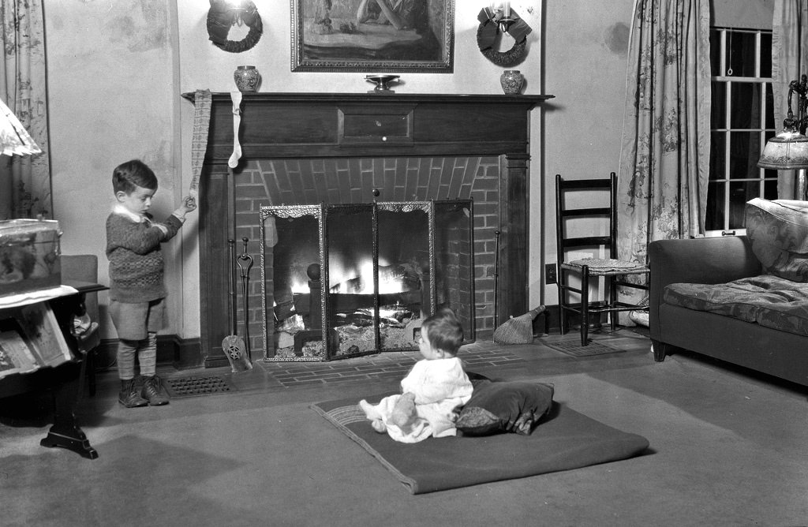

The reference to TV rabbit ears and foil is very age oriented. An alternative. “The same technology thing happens to us rabbits. We used to communicate using land lines. It’s murder using cell phones with these ears. With no pockets we lose them all the time.”

The opening elf line is your first opportunity. The Elf line with Ozzie and Harriet may be too dated for your audience. Try, “Before cell phones, baggage charges on airlines, safety helmets for everything, or edgier “When women stayed home.”

If the Kardashian marriage is old news something more current should be substituted. For example, if this is an in house corporate presentation you could substitute corporate mergers, day care at work, or new IT systems. Whatever works. Local news / references always work. “Construction on Hwy 94.”



“Look who’s on my naughty list.”

CEO of your organization

Or

Everyone at

(Organization Name)

**Costumes:** We purchased a Santa costume and Santa wears the pants, belt, and leggings. Mrs. Claus wears the jacket. For Santa we used a red wool shirt and stuffed a pillow inside to create the appropriate belly. The Santa kit came with a beard. We found it was almost impossible to deliver lines with the beard fully in place. When Santa first enters we have the beard in place and then pull it down a little when Santa’s dialogue starts. We also purchased additional Santa hats at the Dollar Store. The elves created vests and somehow pointed shoes. Typically the audience cannot see our feet, but the elves emphasized their feet with the “bunion line.” Somehow the Easter bunny found a costume that fit. Bunny ears are the key. Fairy Godmother arrives looked bedraggled. Don’t worry about make-up, although rabbit whiskers are fun. Our fairy godmother did a wonderful job with kid’s fairy wings and a spangle top. A tiara, wig off center, wand, all would work. Anything imaginative and garish works.

**Random additional or substitute lines**

**Santa:** I think I will move to the Christmas Islands and grow coconuts.



Bermuda Shorts

Suntan Lotion

Outrigger canoe for a sleigh

Mai Tai’s for the reindeer

**Elf # 1:** Here’s a good one.Dear Santa, Don’t rush off this Christmas. I love a man in uniform. Even better when they bring presents. Come and play house with me. Candy, age 27.

**Santa:** Elf, do you have her phone number.



**Mrs. Claus:** Men, they never stop dreaming.

**Santa:** Now I must put bar codes on the toys. The only bar I am interested in is Hooters.

**Mrs. Claus:** We can have a baby shower and send out e-vites.”

**Santa:** It’s nice of you to try to help. It’s just now everything is G3’s and G4’s, memory cards, hash tags and face book. Oh and now it all in the cloud.

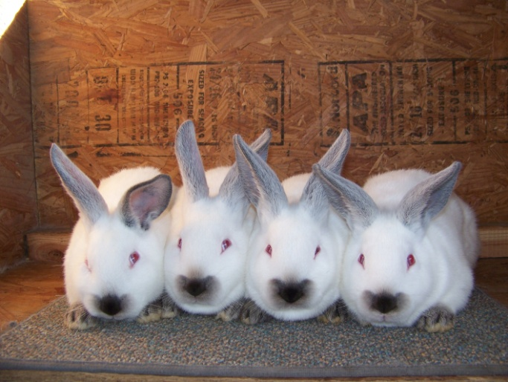

**Bunny:** And of course we are known to reproduce. We love to try.”



**Bunny:** We love to dance…. The hip hop of course.”



Adjust your Run Time

**For a Shorter Run Time:** The run time is approximately 40 minutes. I suggest deleting in the following order.

1. **Elf:** We elves don’t know if we are dwarfs, midgets or simple little green people.
2. **Elf:** To show our frustration we elves wrote this poem.
3. **Elf:** Nothing showing gender in the toys, nothing for just girls or just boys.
4. **Bunny:** Which reminds me, I have a movie audition. Santa you are the star in all the movies and songs that inspire us. I never get beyond the first audition before I am cut. We call it a hare cut. (If there is no laughter add) That’s H.A.R.E.
5. **Santa:** No, nothing medical. Nothing that Nutrisystem or a Dr OZ diet will not solve.
6. **Bunny:** Dr Oz says green coffee beans melt the fat away. **Santa:** I think he really is from OZ. We all know nothing melts away at the North Pole, not even this. (Santa pats his belly). (Need to add “I’m fine.”
7. **Elf:** It all seems so unfair, No children, no heir.
8. **Santa:** Very funny.We are at the North Pole. Haven’t you hear about computers freezing up. I’m just too far behind all this technology. If you ask me Twittering should left to the birds. I’m going to give it up.
9. **Elf:** This is from Nicole age 7. Everything I got says made in China. Have you moved from the North Pole? **Santa:** See, she thinks I’ve retired to China.
10. **Fairy Godmother:** The lawyer – Politian joke.
11. **All singing.**

**Longer Run Time:** There are a number of ways to expand your production time. Add lines first, then music and finally an additional character. Most Christmas music is royalty free.

**Acting Notes**

**Encourage applause**



All Applause is Good

Some audiences get right into applauding, others need a little fuel for the fire.

Elves – applaud off stage for Easter Bunny and Fairy Godmother

1. Santa entering is hunched over, depressed. For the poem Santa does not need to follow the lines. He simply needs to react.
2. **Elf #3:** “And with every toy you can bet there must be a safety strap or helmet.” With this forced rhyme “met” must be emphasized.
3. **Santa: “**Everyone does that. They look alike. Anyway it could have been your mother (Give the humor a chance to develop. After “mother” pause, “and the remote has a pause button.”
4. **Santa**: “It’s another terrible, tumultuous, treacherous, treasonable, tormenting, tradition breaking, technological turn. (emphasizing the T’s). If the actor can deliver this line facing the audience with no notes it will get a stronger response.

**Santa:** “I’m like Rodney Dangerfield. I just don’t get any ………..” (Gesture to the audience to get them to answer)

“Any respect. I’m thinking about retiring. ”

The Rodney Dangerfield reference has worked with all adult age groups.

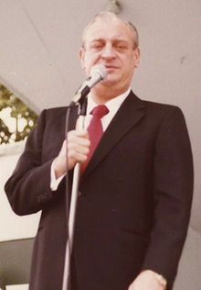

1. **Fairy Godmother entrance**. Stretch this out for effect.

Santa’s Troubles is a Funny Play

Everyone Loves Santa

[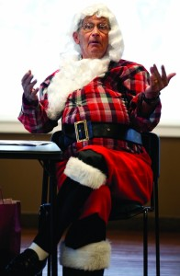](http://pressnews.com/wp-content/uploads/2012/12/MGsantaRetires7.jpg)

So Enjoy the Applause !!

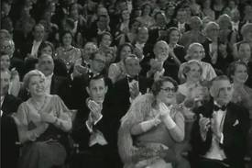

The Holidays are Naturally Festive

Promotional Flyer Template

**“Santa’s Troubles”**

**What If Santa Retired?**

**You be the Judge**





**This Very Funny One Act Play is Presented by**

C:\Documents and Settings\Joe Beach\Local Settings\Temporary Internet Files\Content.IE5\BZVKNKRA\MC900097507[1].wmf

**Add time, place or other information**

Additional Template Materials

**Audience Participation Required – Prepare to laugh**

**The Cast (Listed by age and weight)**

**Santa** ………………………..……Joe Beach

**Elf 1** ………………………………

**Elf 2** ………..……………………

**Elf 3** ……………………………..

**Clara Claus………………… .**

**Easter Bunny** …………………

**Fairy Godmother**………………